**Interpreting ecologies of extinct vertebrates**

**Please direct any questions or queries to Jordan Bestwick** [**jordan.bestwick92@gmail.com**](mailto:jordan.bestwick92@gmail.com)

**Part 1 Introduction**

One fundamental aspect of palaeoecology that palaeontologists wish to understand is diets. This can be challenging given that we cannot observe an extinct organism, and diets even in living organisms can be complex (varying through growth, annually or in different populations). Working out the diets of extinct animals allows palaeontologists to infer various ecological traits and to understand ways that animals interacted with each other and their environments, and to begin to build pictures of past ecological communities. With fossil vertebrates, the evidence available to us most commonly consists of hard tissues, bones and teeth, although other sources of data may be preserved under certain circumstances.

**Q:** **What sources of data are potentially available to understand fossil vertebrate diets and how might these be used? What are some of the limitations of these data?**

In this practical we will focus on a quantitative approach to assessing diets of fossil vertebrates: *dental microwear analysis*. This approach is being utilised by a growing number of palaeontologists to understand diets and dietary evolution of extinct animals, including pterosaurs, dinosaurs and other tetrapods.

Microwear refers to the microscopic textures on tooth surfaces which are formed during feeding as food items causes chipping and scratching of tooth enamel. The material properties of different food items, i.e. the relative difficulty in piercing or crushing items, can result in different types of microwear. One main trend is that animals with higher proportions of “hard” items in their diet exhibit rougher microwear patterns than animals with “soft” diets. This is illustrated below:

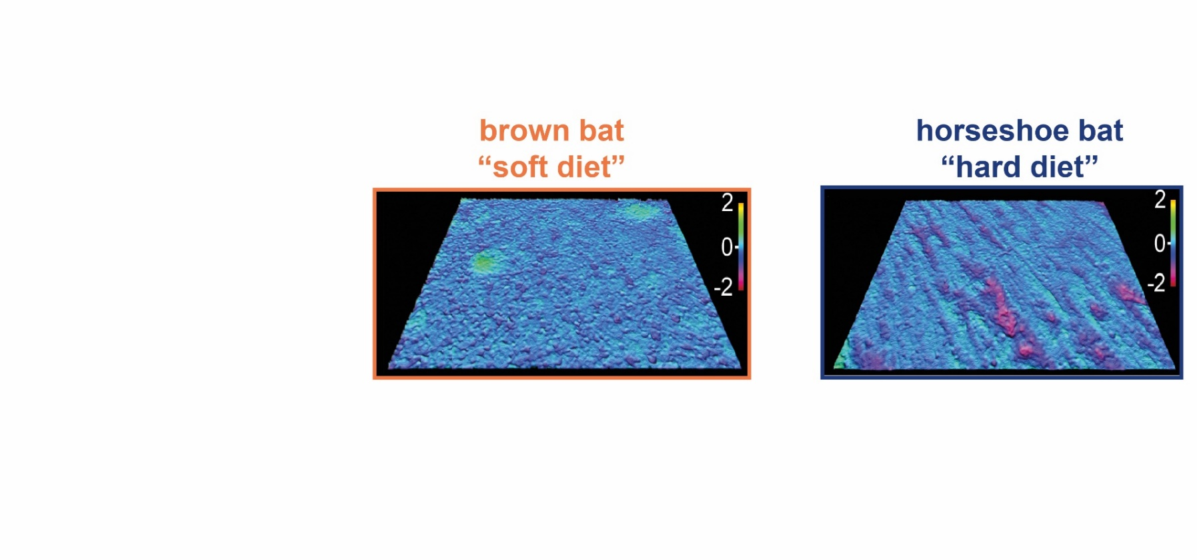

These images are 3D topographic roughness surfaces from the molars of two modern bats, the brown bat and horseshoe bat respectively. These surfaces in life are 110 by 140 micrometres in size, hence the term “microwear”. The purple regions denote troughs roughly two micrometres deep, which are larger and more numerous in the horseshoe bat. These textural differences reflect the known dietary differences between these bats, established from stomach and faecal content studies by ecologists. Horseshoe bats primarily consume beetles, which have thick exoskeletons, and are therefore considered “hard” items. The brown bat consumes butterflies and moths, which have thin exoskeletons, and are therefore “soft”. Microwear formation is therefore not determined by tooth morphology or by preconceptions of possible tooth function.

**Part 2 Importance of using 3D texture data**

Microwear analyses originally consisted of counting numbers of microscopic features, termed scratches and pits, from 2D images of tooth surfaces taken by a light or scanning electron microscope. Tooth surfaces with greater numbers of features per given area were designated as “rougher” and were therefore used to consume harder foods. This was certainly a straightforward and time-effective way of collecting data but was it the most robust? A good example involves three modern African carnivores: the lion (*Panthera leo*), spotted hyena (*Crocuta crocuta*) and cheetah (*Acinonyx jubatus*). These species consume similar animals (antelope, zebra etc.) but they consume different parts of carcasses e.g. softer flesh versus harder bones.

**Task:**  **Click the following links to view 3D skull models of each carnivore. Compare and contrast their anatomy using labels from the cheetah model. Based on morphology, which carnivore is most likely to consume the hardest parts of carcasses? Would their tooth surfaces be the roughest or smoothest?**

Lion (*Panthera leo*) <https://sketchfab.com/3d-models/lion-skull-b7b59f40f37b4ea99a59a16e17d033f9>

Hyena (*Crocuta crocuta*) <https://sketchfab.com/3d-models/cmnh-17686-spotted-hyena-skull-01d86d2c60d44e148991aa97fb666956>

Cheetah (*Acinonyx jubatus*) <https://sketchfab.com/3d-models/cheetah-skull-144c022d794e421490fc462faba00c6c>

**Task:**  **plot the scratch and pit data from the teeth of African carnivores in Excel (or draw on graph paper) to deduce the likely material properties of carnivore diets (no. of pits; x-axis, no. of scratches; y-axis). Is the result what you expected based on the morphology and behaviour of these species?** (Use space on next page to write answers)



Carnassial tooth (lower molar) of a hyena. Microwear is sampled from the enamel facet on the cutting surface of the tooth (dotted area). From Schubert *et al.* (2010).

|  |  |  |
| --- | --- | --- |
| **species** | **No. of scratches** | **No. of pits** |
| cheetah | 25 | 26 |
| cheetah | 20 | 25 |
| cheetah | 15 | 32 |
| cheetah | 9 | 32 |
| cheetah | 10 | 30 |
| cheetah | 20 | 24 |
| cheetah | 21 | 32 |
| hyena | 2 | 27 |
| hyena | 21 | 26 |
| hyena | 15 | 24 |
| hyena | 16 | 25 |
| hyena | 5 | 21 |
| hyena | 10 | 28 |
| hyena | 7 | 23 |
| lion | 25 | 25 |
| lion | 10 | 22 |
| lion | 11 | 22 |
| lion | 12 | 32 |
| lion | 9 | 34 |
| lion | 14 | 29 |
| lion | 10 | 34 |

This example highlights some of the flaws of visually identifying microwear features from images. In more recent years palaeontologists have used texture parameters to quantify microwear differences between species. There are 22 such parameters but we will focus on two here; average peak volume and average trough volume (both measured in micrometres3/millimetre3). Surface textures with larger peak and/or trough volume are considered rougher and are formed by diets with more hard items, as illustrated below. N.B. the schematic is a 2D representation of volumetric parameters.

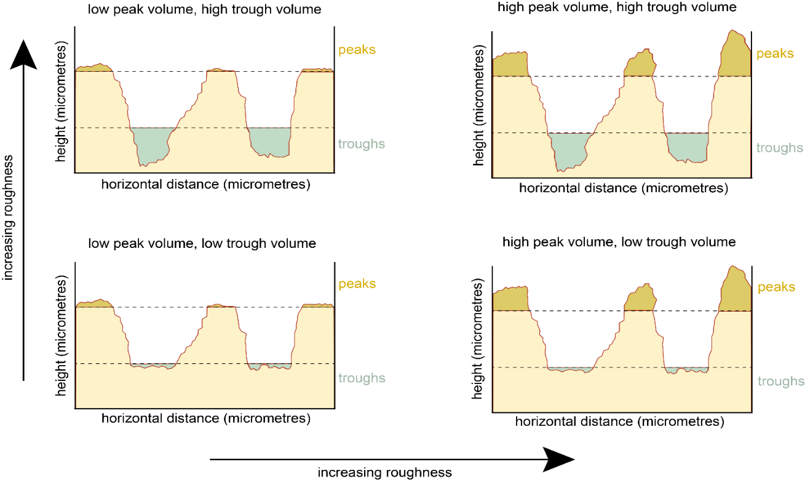

Understanding the relationship between microwear characteristics and modern animals with different diets allows us to use modern animals as analogues to compare with microwear from extinct animals. N.B. We cannot explicitly say that “extinct animal A has the same microwear as modern animal B so extinct animal A also ate items X and Y”, but rather “extinct animal A ate food items with the same material properties as in the modern animal B diet”.

**Q: What are the advantages of using textures parameters to deduce microwear differences between animals with different diets, rather than by visually identifying features?**

**Task:** **plot the African carnivore 3D microwear data in Excel (or draw on graph paper) to deduce the likely material properties of carnivore diets (average peak volume; x-axis, average trough volume; y-axis). Is the result more like what we would expect based on known behaviours?**

|  |  |  |
| --- | --- | --- |
| **species** | **average peak volume (micrometres3/millimetre3)** | **average trough volume (micrometres3/millimetre3)** |
| cheetah | 2.34 | 2.43 |
| cheetah | 2.16 | 2.45 |
| cheetah | 2.25 | 2.13 |
| cheetah | 1.76 | 2.8 |
| cheetah | 2.14 | 2.24 |
| cheetah | 2.61 | 2.45 |
| cheetah | 2.1 | 2.61 |
| hyena | 5.72 | 5.79 |
| hyena | 5.56 | 5.34 |
| hyena | 4.87 | 5.51 |
| hyena | 5.02 | 4.89 |
| hyena | 5.27 | 5.09 |
| hyena | 5.33 | 5.63 |
| hyena | 5.12 | 5.65 |
| lion | 3.5 | 4.75 |
| lion | 4.1 | 3.8 |
| lion | 3.9 | 3.2 |
| lion | 4.79 | 4.16 |
| lion | 4.72 | 4.96 |
| lion | 4.57 | 3.67 |
| lion | 3.79 | 4.36 |

Nowadays, 3D analyses are the most commonly employed method for reconstructing extinct diets. The 3D microwear data of the African carnivores were therefore used as extant analogues for reconstructing the diets of two North American carnivores that went extinct at the end of the most recent Ice Age, the American lion, *Panthera atrox* and the famous saber-toothed cat *Smiliodon fatalis*.

**Q: What characteristics make some modern animals more suitable than others as analogues for analysing microwear from extinct animals?**

**Q: Compare the 3D models of the skulls of *P. atrox* and *Smilodon*. Based on morphology alone, which of the two cats would think would have the roughest microwear textures and therefore likely fed on the harder parts of carcasses?**

American lion (*Panthera atrox*) <https://sketchfab.com/3d-models/american-lion-abaa8a7cb7514a3893f4a4cb82ef6d99>

*Smilodon fatalis* <https://sketchfab.com/3d-models/smilodon-fatalis-47feca45057c4da58d063522714084c9>

**Task: Add the *Panthera atrox* and *Smilodon* microwear data to the African carnivore 3D dataset in Excel (or draw on graph paper) to deduce the likely material properties of Pleistocene carnivore diets (average peak volume; x-axis, average trough volume; y-axis). Is this result expected based on morphology?** (Use space on next page to write answers)

|  |  |  |
| --- | --- | --- |
| **species** | **average peak volume (micrometres3/millimetre3)** | **average trough volume (micrometres3/millimetre3)** |
| *Panthera atrox* | 3.2 | 3.5 |
| *Panthera atrox* | 3.46 | 3.24 |
| *Panthera atrox* | 3.06 | 2.98 |
| *Panthera atrox* | 3.1 | 3.08 |
| *Smilodon* | 4.01 | 3.82 |
| *Smilodon* | 3.4 | 3.65 |
| *Smilodon* | 3.44 | 4.1 |
| *Smilodon* | 3.67 | 4.8 |

**Part 3 Microwear Case-Studies**

Below are a couple more case-studies of microwear research done by palaeontologists. Each case-study includes a series of microwear data (peak volume and trough volume) for students to plot in Microsoft Excel (or draw on graph paper). Students must interpret this data to infer the likely material properties of the diets of extinct animals and draw conclusions about the dietary ecology and dietary evolution of past ecosystems.

To aid with data interpretation, 3D models of some tooth surfaces are provided online at <https://sketchfab.com/microwear/models> individual links given below. Clicking the link will provide the option to choose one of six textures (models may take a few seconds to load). Moving the cursor on the texture will reveal a menu in the bottom right corner. Click ‘Model Inspector’ which opens another menu on the left. Click ‘Matcap’ which will show the texture in 3D and this can be zoomed in and toggled.

**Case-study 1:** In the shadow of dinosaurs

The dominance of dinosaurs prevented other animals from occupying many ecological roles within habitats. Mammaliaforms (close relatives of ‘true’ mammals) evolved around the same time as dinosaurs (~220 million years ago), but as the latter occupied most ecological roles, mammaliaforms are thought to have been simply small insectivores. However, recent discoveries have shown they possessed a wider range of adaptations that enabled them to occupy a greater number of habitats and consume a greater range of foods. Palaeontologists have therefore tested for dietary variation in mammaliaforms using microwear.

Two mammaliaforms of interest are *Morganucodon* (More – gun – oo– koh – don) and *Kuehneotherium* (Queue – knee - oh – theer – ree – um). These species lived ~200 million years ago in South Wales, UK. Microwear can thus test whether these species competed for food in the same ecosystems.

Modern shrews are used as mammaliaform analogues because: 1) they have similar tooth morphologies to mammaliaforms; 2) they are similar sized; and 3) they live in similar environments (i.e. woodlands). Two analogues are the Eurasian water shrew (*Neomys fodiens*) and the Eurasian pygmy shrew (*Sorex minutus*). These shrews are from the same woodland areas of Poland but eat different foods; the water shrew mainly eats snails and earthworms, whereas the pygmy shrew predominately eats beetles, spiders and ants.

**Task: plot the shrew and mammaliaform microwear data in Excel (or draw on graph paper) to deduce the likely material properties of mammaliaforms (average peak volume; x-axis, average trough volume; y-axis). Use the previous diagrams and online surfaces to help.**

Eurasian water shrew cranium (*Neomys fodiens*) <https://sketchfab.com/3d-models/neomys-fodiens-eurasian-water-shrew-b2aaca2145904d53a3a6ff1831041df5>

Pygmy shrew skeleton (*Sorex minutus*) <https://sketchfab.com/3d-models/sorex-minutus-eurasian-pygmy-shrew-a179bb6602544945a1091b2dfa010f93>

Water shrew microwear

<https://sketchfab.com/3d-models/eurasian-water-shrew-8519ab75cc1c4123a2251005e6c20483>

*Morganucodon* microwear

<https://sketchfab.com/3d-models/morganucodon-2adb61fe31c943e39707377967fff2d2>

|  |  |  |
| --- | --- | --- |
| **species** | **average peak volume (micrometres3/millimetre3)** | **average trough volume (micrometres3/millimetre3)** |
| water shrew | 3.58 | 3.20 |
| water shrew | 3.60 | 3.04 |
| water shrew | 3.44 | 3.08 |
| water shrew | 3.81 | 3.06 |
| water shrew | 3.65 | 3.15 |
| pygmy shrew | 5.31 | 4.53 |
| pygmy shrew | 5.30 | 4.82 |
| pygmy shrew | 5.16 | 4.60 |
| pygmy shrew | 5.65 | 4.59 |
| pygmy shrew | 5.02 | 4.60 |
| *Kuehneotherium* | 2.98 | 2.26 |
| *Kuehneotherium* | 2.59 | 2.54 |
| *Kuehneotherium* | 2.96 | 2.44 |
| *Kuehneotherium* | 2.94 | 2.31 |
| *Kuehneotherium* | 2.55 | 2.49 |
| *Morganucodon* | 5.60 | 5.97 |
| *Morganucodon* | 5.43 | 5.21 |
| *Morganucodon* | 5.83 | 5.22 |
| *Morganucodon* | 5.51 | 5.03 |
| *Morganucodon* | 5.16 | 5.39 |

**Q: Based on the graph, what can be said about the material properties of beetles, earthworms and snails? i.e. are they soft or hard food items?**

**Q: What can be inferred about the diets of these mammaliaforms based on the graph?**

**Q: What are the limitations of these analyses and how could they be expanded further to understand early mammaliaform diets?**

**Q: Additionally, would where the shrew eats affect the microwear texture? For example: eating earthworms might incorporate some mud/sediment into their diet – could this affect the microwear?**

**Case-study 2:** Lagoonal pterosaurs

Pterosaurs (Tare-o-saws) are extinct flying reptiles who lived from 210–66 million years ago. Pterosaur diets have been speculated for decades with little to no scientific testing of these ideas. This case study concerns pterosaurs from Solnhofen in Germany, 150 million years ago. Back then, Solnhofen was a coastal lagoonal environment with sea water washing into lagoons and partially evaporating, resulting in salty lagoons.

Solnhofen contains well-preserved fossils of several pterosaur species, including *Pterodactylus* (Tare-o-dack-tie-lus) and *Rhamphorhynchus* (Ram-for-rin-cus). These pterosaurs are thought to have consumed different foods using their different teeth; *Rhamphorhynchus* has slender, curved teeth and is thought to have fed on fish. *Pterodactylus* has straight, triangular teeth and is thought to have been an opportunist.

Crocodilians are used as pterosaur analogues because: 1) they have similar tooth morphologies to pterosaurs; 2) they live in similar environments (i.e. lakes, rivers and coastlines); and 3) are the closest living toothed relatives of pterosaurs (birds are more closely related but they have no teeth). Two analogues include the American alligator (*Alligator mississippiensis*) and American crocodile (*Crocodylus acutus*), both from Florida, USA. The alligator primarily consumes fish and the crocodile primarily consumes crustaceans such as crabs.

**Task;** **plot the crocodilian and pterosaur microwear data in Excel (or draw on graph paper) to deduce the likely material properties of pterosaur diets (average peak volume; x-axis, average trough volume; y-axis). Use the online diagrams and tooth surfaces to help.**

American alligator (*Alligator mississippiensis*)

<https://sketchfab.com/3d-models/alligator-skull-47e21ba8ab594048a5e6174938a46665>

American crocodile (*Crocodylus acutus*)

<https://sketchfab.com/3d-models/american-crocodile-skull-8dc8817a04a4477db22200f53a9c01f7>

*Rhamphorhynchus*

<https://sketchfab.com/3d-models/rhamphorhynchus-2dff2bded9af46afbc6ae0c10848776a>

*Pterodactylus*

<https://sketchfab.com/3d-models/pterodactylus-d71001a1336743509dca5cb053b1f287>

(N.B. the wing membrane should connect just above the ankles, not at the knees as in this model.

*Alligator* microwear

<https://sketchfab.com/3d-models/american-alligator-b04a0b061cf040dcaadbd5261270b68c>

*Rhamphorhynchus* microwear

<https://sketchfab.com/3d-models/rhamphorhynchus-af7a008a356f47d4b63545bad84678dc>

|  |  |  |
| --- | --- | --- |
| **species** | **average peak volume (micrometres3/millimetre3)** | **average trough volume (micrometres3/millimetre3)** |
| American alligator | 2.12 | 3.24 |
| American alligator | 1.89 | 3.09 |
| American alligator | 2.56 | 2.79 |
| American alligator | 2.07 | 2.81 |
| American alligator | 2.83 | 1.59 |
| American alligator | 1.87 | 2.34 |
| American crocodile | 5.73 | 4.59 |
| American crocodile | 5.18 | 4.32 |
| American crocodile | 4.89 | 3.68 |
| American crocodile | 5.23 | 4.76 |
| American crocodile | 5.37 | 4.98 |
| American crocodile | 5.6 | 4.78 |
| American crocodile | 5.57 | 5.08 |
| *Pterodactylus* | 4.1 | 4.38 |
| *Pterodactylus* | 4.67 | 4.02 |
| *Pterodactylus* | 5.01 | 3.97 |
| *Pterodactylus* | 4.89 | 4.82 |
| *Pterodactylus* | 4.63 | 4.02 |
| *Pterodactylus* | 4.7 | 4.64 |
| *Rhamphorhynchus* | 2.58 | 2.89 |
| *Rhamphorhynchus* | 2.74 | 3.14 |
| *Rhamphorhynchus* | 2.97 | 2.54 |
| *Rhamphorhynchus* | 2.68 | 1.89 |
| *Rhamphorhynchus* | 3.09 | 1.94 |
| *Rhamphorhynchus* | 2.78 | 2.86 |

**Q: Based on your results, what can be said about the material properties of fish and crustaceans i.e. are they soft or hard food items?**

**Q: What can be inferred about the diets of these pterosaurs based on the graph? Did they likely compete with each other?**

**Optional extra: Age dependent diets in pterosaurs?**

The above examples show that microwear analyses are a powerful tool for reconstructing the diets of extinct species. But can we go further and investigate dietary differences *within* a species? *Rhamphorhynchus* is an exceptionally preserved pterosaur in that we have fossils from every age of this species from hatchlings to adults. See Bennett (1995), fig. 5, to see how much these animals grow with age. Palaeontologists have long debated whether pterosaurs actively looked after their young, such as feeding their newly-hatched offspring, with few conclusive findings. Microwear analysis can provide another piece towards answering this puzzle.

**Task;** **add the juvenile and hatchling *Rhamphorhynchus* microwear data to the existing pterosaur plot to deduce whether material properties of *Rhamphorhynchus* diets change with age.**

|  |  |  |
| --- | --- | --- |
| **species** | **average peak volume (micrometres3/millimetre3)** | **average trough volume (micrometres3/millimetre3)** |
| *Rhamph*. Juv | 3.5 | 3.46 |
| *Rhamph*. Juv | 3.76 | 3.24 |
| *Rhamph*. Juv | 3.98 | 4.15 |
| *Rhamph*. Juv | 4.23 | 3.5 |
| *Rhamph*. hatchling | 4.5 | 4.8 |
| Rhamph. hatchling | 4.67 | 4.89 |
| *Rhamph*. hatchling | 4.2 | 4.9 |

**Q: Based on your results, what can be said about the diets of *Rhamphorhynchus* with increasing age? What implications does this have with regards to pterosaur competition in Solnhofen?**

**Q: Thinking about reproductive strategies of modern birds and reptiles with regards how parents look after their young, which strategy do you think *Rhamphorhynchus* is most like based on the microwear data?**

**Key references:**

Bennett SC 1995 A statistical study of *Rhamphorhynchus* from the Solnhofen Limestone of Germany: year-classes of a single large species*. Journal of Paleontology* **69**: 569–580.

Bestwick J *et al.* 2020. Dietary diversity and evolution of the earliest true flying vertebrates revealed by dental microwear texture analysis. [*Nature Communications* **11**: 5293](https://www.nature.com/articles/s41467-020-19022-2).

DeSantis LRG *et al.* 2012. Implications of diet for the extinction of saber-toothed cats and American lions. *PLoS ONE* **7**: e52453.

DeSantis LRG *et al.* 2013. Direct comparisons of 2D and 3D dental microwear proxies in extant herbivorous and carnivorous mammals. *PLoS ONE* **8**: e71428.

Gill PG *et al*. 2014. Dietary specializations and diversity in feeding ecology of the earliest stem mammals. [*Nature* **512**: 303–305](https://www.nature.com/articles/nature13622).

Schubert BW et al. 2010. Carnassial microwear and dietary behaviour in large carnivorans. *Journal of Zoology* **280**: 257–263.