**Interpreting ecologies of extinct vertebrates**

**ANSWERS TO QUESTIONS AND EXAMPLE PLOTS ARE SHOWN BELOW IN RED**

**Please direct any questions or queries to Jordan Bestwick** [**jordan.bestwick92@gmail.com**](mailto:jordan.bestwick92@gmail.com)

**Part 1 Introduction**

One fundamental aspect of palaeoecology that palaeontologists wish to understand is diets. This can be challenging given that we cannot observe an extinct organism, and diets even in living organisms can be complex (varying through growth, annually or in different populations). Working out the diets of extinct animals allows palaeontologists to infer various ecological traits and to understand ways that animals interacted with each other and their environments, and to begin to build pictures of past ecological communities. With fossil vertebrates, the evidence available to us most commonly consists of hard tissues, bones and teeth, although other sources of data may be preserved under certain circumstances.

**Q:** **What sources of data are potentially available to understand fossil vertebrate diets and how might these be used? What are some of the limitations of these data?**

Methods include:

* Analysing fossilised stomach contents, coprolites or regurgitates
* Comparing the shapes of teeth with those of modern animals with known diets (known as comparative anatomy).

Different tooth shapes can indicate different methods of feeding – some teeth are more suitable for biting and chewing, others are more suited for ripping flesh. Sometimes scientists use these tooth shapes to generate ideas of what extinct animals used to eat.

Stomach contents are extremely rare and only provide evidence for the last meal an animal ate. Coprolites and regurgitates may be difficult to associate positively with a species. Tooth shape doesn’t necessarily tell you about the possible diet of an animal. A good example are modern bears as they have very similar tooth shapes but exhibit very different diets; polar bears (*Ursus maritimus*) are strict carnivores, primarily consuming seals. Grizzly bears (*Ursus arctos*) are omnivores, consuming deer, fish and also berries, while giant pandas (*Ailuropoda melanoleuca*) are herbivores, subsisting entirely on bamboo. If you had to work out the diets of these bears just from their teeth shapes, you would likely conclude that they all ate the same or similar foods.

In this practical we will focus on a quantitative approach to assessing diets of fossil vertebrates: *dental microwear analysis*. This approach is being utilised by a growing number of palaeontologists to understand diets and dietary evolution of extinct animals, including pterosaurs, dinosaurs and other tetrapods.

Microwear refers to the microscopic textures on tooth surfaces which are formed during feeding as food items causes chipping and scratching of tooth enamel. The material properties of different food items, i.e. the relative difficulty in piercing or crushing items, can result in different types of microwear. One main trend is that animals with higher proportions of “hard” items in their diet exhibit rougher microwear patterns than animals with “soft” diets. This is illustrated below:

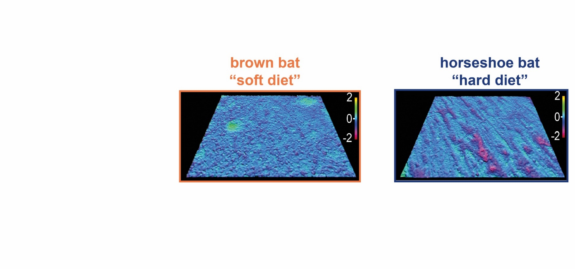

These images are 3D topographic roughness surfaces from the molars of two modern bats, the brown bat and horseshoe bat respectively. These surfaces in life are 110 by 140 micrometres in size, hence the term “microwear”. The purple regions denote troughs roughly two micrometres deep, which are larger and more numerous in the horseshoe bat. These textural differences reflect the known dietary differences between these bats, established from stomach and faecal content studies by ecologists. Horseshoe bats primarily consume beetles, which have thick exoskeletons, and are therefore considered “hard” items. The brown bat consumes butterflies and moths, which have thin exoskeletons, and are therefore “soft”. Microwear formation is therefore not determined by tooth morphology or by preconceptions of possible tooth function.

**Part 2 Importance of using 3D texture data**

Microwear analyses originally consisted of counting numbers of microscopic features, termed scratches and pits, from 2D images of tooth surfaces taken by a light or scanning electron microscope. Tooth surfaces with greater numbers of features per given area were designated as “rougher” and were therefore used to consume harder foods. This was certainly a straightforward and time-effective way of collecting data but was it the most robust? A good example involves three modern African carnivores: the lion (*Panthera leo*), spotted hyena (*Crocuta crocuta*) and cheetah (*Acinonyx jubatus*). These species consume similar animals (antelope, zebra etc.) but they consume different parts of carcasses e.g. softer flesh versus harder bones.

**Task:**  **Click the following links to view 3D skull models of each carnivore. Compare and contrast their anatomy using labels from the cheetah model. Based on morphology, which carnivore is most likely to consume the hardest parts of carcasses? Would their tooth surfaces be the roughest or smoothest?**

Lion (*Panthera leo*) <https://sketchfab.com/3d-models/lion-skull-b7b59f40f37b4ea99a59a16e17d033f9>

Hyena (*Crocuta crocuta*) <https://sketchfab.com/3d-models/cmnh-17686-spotted-hyena-skull-01d86d2c60d44e148991aa97fb666956>

Cheetah (*Acinonyx jubatus*) <https://sketchfab.com/3d-models/cheetah-skull-144c022d794e421490fc462faba00c6c>

Based on morphology alone, the hyena shows the strongest adaptations for consumption of harder parts of carcasses, followed by the lion, with cheetahs most likely to consume the softest parts of carcasses (i.e. the flesh). The hyena would theoretically have the roughest textures, followed by the lion then the cheetah.

Main morphological indicators:

* When in lateral (side) view, the hyena has the most prominent saggital crest (label no. 6 on the cheetah model) and tallest coronoid process (label 10). These adaptations provide more muscle attachment sites for muscles, providing a stronger bite.
* When in dorsal (top) view, the hyena has the most prominent bowing of the zygomatic arch (label 7). This provides more room for larger jaw muscles, providing a stronger bite.
* The carnassial teeth (label 2) of the hyena are the largest and most robust of the three. These teeth are therefore better suited for dealing with large amounts of stress from strong bites.

**Task:**  **plot the scratch and pit data from the teeth of African carnivores in Excel (or draw on graph paper) to deduce the likely material properties of carnivore diets (no. of pits; x-axis, no. of scratches; y-axis). Is the result what you expected based on the morphology and behaviour of these species?**



Carnassial tooth (lower molar) of a hyena. Microwear is sampled from the enamel facet on the cutting surface of the tooth (dotted area). From Schubert *et al.* (2010).

|  |  |  |
| --- | --- | --- |
| **species** | **No. of scratches** | **No. of pits** |
| cheetah | 25 | 26 |
| cheetah | 20 | 25 |
| cheetah | 15 | 32 |
| cheetah | 9 | 32 |
| cheetah | 10 | 30 |
| cheetah | 20 | 24 |
| cheetah | 21 | 32 |
| hyena | 2 | 27 |
| hyena | 21 | 26 |
| hyena | 15 | 24 |
| hyena | 16 | 25 |
| hyena | 5 | 21 |
| hyena | 10 | 28 |
| hyena | 7 | 23 |
| lion | 25 | 25 |
| lion | 10 | 22 |
| lion | 11 | 22 |
| lion | 12 | 32 |
| lion | 9 | 34 |
| lion | 14 | 29 |
| lion | 10 | 34 |

Answer

The graph should look like below, with lots of overlap between the carnivores and no discernable patterns or differences. This is not what we would expect based on morphological assessments from the previous task. Moreover, this does not corroborate with what we know from field observations, as hyenas are renowned for consuming carcass bones while cheetahs restrict themselves to the soft, fleshy parts of carcasses.

This example highlights some of the flaws of visually identifying microwear features from images. In more recent years palaeontologists have used texture parameters to quantify microwear differences between species. There are 22 such parameters but we will focus on two here; average peak volume and average trough volume (both measured in micrometres3/millimetre3). Surface textures with larger peak and/or trough volume are considered rougher and are formed by diets with more hard items, as illustrated below. N.B. the schematic is a 2D representation of volumetric parameters.

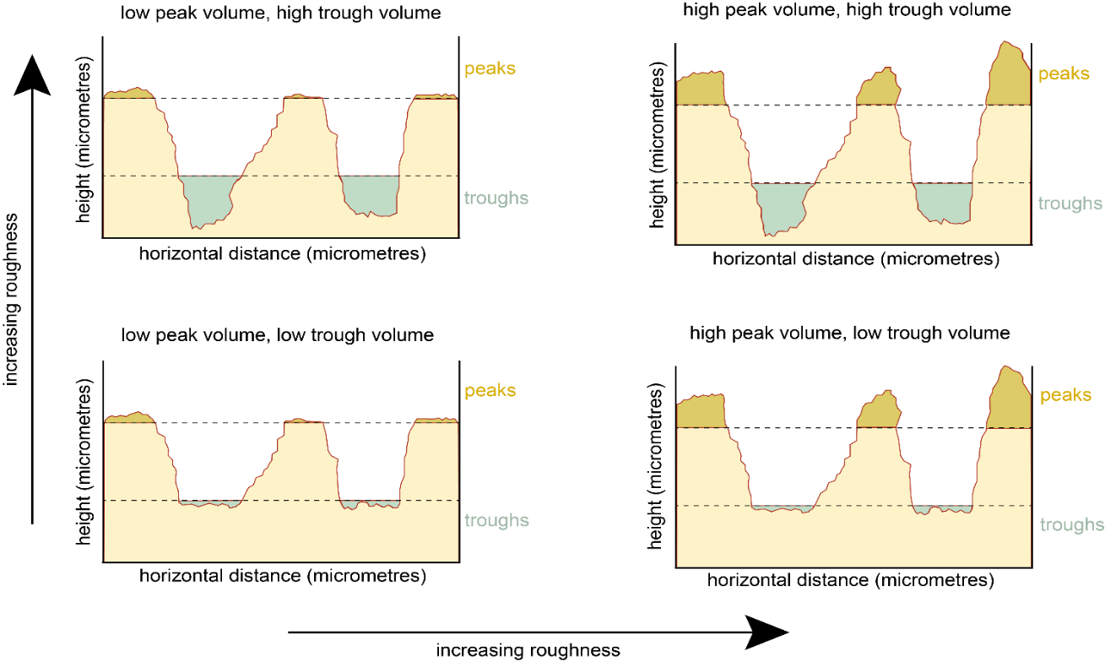

Understanding the relationship between microwear characteristics and modern animals with different diets allows us to use modern animals as analogues to compare with microwear from extinct animals. N.B. We cannot explicitly say that “extinct animal A has the same microwear as modern animal B so extinct animal A also ate items X and Y”, but rather “extinct animal A ate food items with the same material properties as in the modern animal B diet”.

**Q: What are the advantages of using textures parameters to deduce microwear differences between animals with different diets, rather than by visually identifying features?**

* Texture parameters are more quantifiable and representative There is currently no accepted definition about constitutes as a scratch or a pit on a tooth surface which can cause confusion. Texture parameters in contrast have and official definitions which makes data between taxa more representative.
* Eliminates within-person error i.e. someone examining 2D microwear over a period of time may have their judgement unknowingly affected by factors such as time of day, illness etc. This may lead to unrepresentative conclusions drawn from inconsistent results.
* Eliminates between-person error i.e. multiple people identifying 2D features may disagree as to what qualifies as a scratch or pit. This may lead to unrepresentative conclusions from inconsistent results.
* Visual identification of features relies on single-angled light from a microscope. Many standard microscopes provide light from only one angle which can accidentally ‘hide’ microwear features. Generating 3D surfaces avoids this problem (although this requires a much more expensive microscope).

**Task:** **plot the African carnivore 3D microwear data in Excel (or draw on graph paper) to deduce the likely material properties of carnivore diets (average peak volume; x-axis, average trough volume; y-axis). Is the result more like what we would expect based on known behaviours?**

|  |  |  |
| --- | --- | --- |
| **species** | **average peak volume (micrometres3/millimetre3)** | **average trough volume (micrometres3/millimetre3)** |
| cheetah | 2.34 | 2.43 |
| cheetah | 2.16 | 2.45 |
| cheetah | 2.25 | 2.13 |
| cheetah | 1.76 | 2.8 |
| cheetah | 2.14 | 2.24 |
| cheetah | 2.61 | 2.45 |
| cheetah | 2.1 | 2.61 |
| hyena | 5.72 | 5.79 |
| hyena | 5.56 | 5.34 |
| hyena | 4.87 | 5.51 |
| hyena | 5.02 | 4.89 |
| hyena | 5.27 | 5.09 |
| hyena | 5.33 | 5.63 |
| hyena | 5.12 | 5.65 |
| lion | 3.5 | 4.75 |
| lion | 4.1 | 3.8 |
| lion | 3.9 | 3.2 |
| lion | 4.79 | 4.16 |
| lion | 4.72 | 4.96 |
| lion | 4.57 | 3.67 |
| lion | 3.79 | 4.36 |

Answer

The graph should look like below, with the cheetah plotting most strongly towards the bottom left of the figure, with the hyena plotting most strongly in the top right and the lion in between. Based on their separation, we can deduce that these carnivores do have different degrees of carcass utilisation, which corroborates with the known behaviours of these animals, and that the lion is more similar to the hyena than to the cheetah.

Nowadays, 3D analyses are the most commonly employed method for reconstructing extinct diets. The 3D microwear data of the African carnivores were therefore used as extant analogues for reconstructing the diets of two North American carnivores that went extinct at the end of the most recent Ice Age, the American lion, *Panthera atrox* and the famous saber-toothed cat *Smiliodon fatalis*.

**Q: What characteristics make some modern animals more suitable than others as analogues for analysing microwear from extinct animals?**

The following characteristics are not mutually exclusive and are in no particular order:

* Similar tooth morphology. Although mentioned previously that tooth morphology of can be flawed, using modern animals with similar tooth morphologies to extinct animal(s) allows for an independent technique to test if morphology-based ideas of diet hold true.
* Similar size. Similar-sized animals are more likely to feed on similar-sized items, making it easier to establish if microwear differences are due to food material properties and not by the physical size of items.
* Evolutionary relatedness. Modern and extinct animals that share recent common ancestors are more likely to have similar tooth structures (e.g. enamel compositions), which facilitates representative comparisons.
* Similar inhabited environments. Animals that inhabit similar environments are more likely to have similar lifestyles. For example, if using a modern desert-dwelling animal as an analogue for a marine extinct animal, it would be difficult to know if microwear differences are due to dietary differences or are an artefact of different habitats.

N.B. It is unlikely that modern animals perfectly meet all these criteria as many extinct animals are unlike any animal alive today. The important concept to understand is that some modern animals will be better analogues than others and that careful consideration that is needed when choosing them.

**Q: Compare the 3D models of the skulls of *P. atrox* and *Smilodon*. Based on morphology alone, which of the two cats would think would have the roughest microwear textures and therefore likely fed on the harder parts of carcasses?**

American lion (*Panthera atrox*) <https://sketchfab.com/3d-models/american-lion-abaa8a7cb7514a3893f4a4cb82ef6d99>

*Smilodon fatalis* <https://sketchfab.com/3d-models/smilodon-fatalis-47feca45057c4da58d063522714084c9>

While *Smilodon* has the more prominent saggital crest, *P. atrox* has the higher coronoid process and slightly more bowed zygomatic arch. We would therefore expect *P. atrox* to have the rougher microwear textures based on morphology alone.

**Task: Add the *Panthera atrox* and *Smilodon* microwear data to the African carnivore 3D dataset in Excel (or draw on graph paper) to deduce the likely material properties of Pleistocene carnivore diets (average peak volume; x-axis, average trough volume; y-axis). Is this result expected based on morphology?**

|  |  |  |
| --- | --- | --- |
| **species** | **average peak volume (micrometres3/millimetre3)** | **average trough volume (micrometres3/millimetre3)** |
| *Panthera atrox* | 3.2 | 3.5 |
| *Panthera atrox* | 3.46 | 3.24 |
| *Panthera atrox* | 3.06 | 2.98 |
| *Panthera atrox* | 3.1 | 3.08 |
| *Smilodon* | 4.01 | 3.82 |
| *Smilodon* | 3.4 | 3.65 |
| *Smilodon* | 3.44 | 4.1 |
| *Smilodon* | 3.67 | 4.8 |

Answer

The graph should look like below, with *P. atrox* and *Smilodon* having very similar microwear textures to each other and to the African lion, although *Smilodon* has slightly larger degrees of overlap with the African lion than what *P. atrox* does. From this result, it can be inferred that perhaps Smilodon used its carnassials to process slightly harder parts of carcasses than *P. atrox*. This is contradictory to what the morphology suggests and challenges views on how fragile the famous saber-teeth were. This example highlights the power of microwear analyses in challenging long-held assumptions of an extinct animal’s ecology based on morphology alone.

**Part 3 Microwear Case-Studies**

Below are a couple more case-studies of microwear research done by palaeontologists. Each case-study includes a series of microwear data (peak volume and trough volume) for students to plot in Microsoft Excel (or draw on graph paper). Students must interpret this data to infer the likely material properties of the diets of extinct animals and draw conclusions about the dietary ecology and dietary evolution of past ecosystems.

To aid with data interpretation, 3D models of some tooth surfaces are provided online at <https://sketchfab.com/microwear/models> individual links given below. Clicking the link will provide the option to choose one of six textures (models may take a few seconds to load). Moving the cursor on the texture will reveal a menu in the bottom right corner. Click ‘Model Inspector’ which opens another menu on the left. Click ‘Matcap’ which will show the texture in 3D and this can be zoomed in and toggled.

**Case-study 1:** In the shadow of dinosaurs

The dominance of dinosaurs prevented other animals from occupying many ecological roles within habitats. Mammaliaforms (close relatives of ‘true’ mammals) evolved around the same time as dinosaurs (~220 million years ago), but as the latter occupied most ecological roles, mammaliaforms are thought to have been simply small insectivores. However, recent discoveries have shown they possessed a wider range of adaptations that enabled them to occupy a greater number of habitats and consume a greater range of foods. Palaeontologists have therefore tested for dietary variation in mammaliaforms using microwear.

Two mammaliaforms of interest are *Morganucodon* (More – gun – oo– koh – don) and *Kuehneotherium* (Queue – knee - oh – theer – ree – um). These species lived ~200 million years ago in South Wales, UK. Microwear can thus test whether these species competed for food in the same ecosystems.

Modern shrews are used as mammaliaform analogues because: 1) they have similar tooth morphologies to mammaliaforms; 2) they are similar sized; and 3) they live in similar environments (i.e. woodlands). Two analogues are the Eurasian water shrew (*Neomys fodiens*) and the Eurasian pygmy shrew (*Sorex minutus*). These shrews are from the same woodland areas of Poland but eat different foods; the water shrew mainly eats snails and earthworms, whereas the pygmy shrew predominately eats beetles, spiders and ants.

**Task: plot the shrew and mammaliaform microwear data in Excel (or draw on graph paper) to deduce the likely material properties of mammaliaforms (average peak volume; x-axis, average trough volume; y-axis). Use the previous diagrams and online surfaces to help.**

Eurasian water shrew cranium (*Neomys fodiens*) <https://sketchfab.com/3d-models/neomys-fodiens-eurasian-water-shrew-b2aaca2145904d53a3a6ff1831041df5>

Pygmy shrew skeleton (*Sorex minutus*) <https://sketchfab.com/3d-models/sorex-minutus-eurasian-pygmy-shrew-a179bb6602544945a1091b2dfa010f93>

Water shrew microwear

<https://sketchfab.com/3d-models/eurasian-water-shrew-8519ab75cc1c4123a2251005e6c20483>

*Morganucodon* microwear

<https://sketchfab.com/3d-models/morganucodon-2adb61fe31c943e39707377967fff2d2>

|  |  |  |
| --- | --- | --- |
| **species** | **average peak volume (micrometres3/millimetre3)** | **average trough volume (micrometres3/millimetre3)** |
| water shrew | 3.58 | 3.20 |
| water shrew | 3.60 | 3.04 |
| water shrew | 3.44 | 3.08 |
| water shrew | 3.81 | 3.06 |
| water shrew | 3.65 | 3.15 |
| pygmy shrew | 5.31 | 4.53 |
| pygmy shrew | 5.30 | 4.82 |
| pygmy shrew | 5.16 | 4.60 |
| pygmy shrew | 5.65 | 4.59 |
| pygmy shrew | 5.02 | 4.60 |
| *Kuehneotherium* | 2.98 | 2.26 |
| *Kuehneotherium* | 2.59 | 2.54 |
| *Kuehneotherium* | 2.96 | 2.44 |
| *Kuehneotherium* | 2.94 | 2.31 |
| *Kuehneotherium* | 2.55 | 2.49 |
| *Morganucodon* | 5.60 | 5.97 |
| *Morganucodon* | 5.43 | 5.21 |
| *Morganucodon* | 5.83 | 5.22 |
| *Morganucodon* | 5.51 | 5.03 |
| *Morganucodon* | 5.16 | 5.39 |

Answers

The graph should look like below, with *Morganucodon* plotting slightly to the right and above the pygmy shrew, and *Kuehneotherium* plotting slightly below and left of the water shrew.

**Q: Based on the graph, what can be said about the material properties of beetles, earthworms and snails? i.e. are they soft or hard food items?**

The complete separation of the water shrew and pygmy shrew from each other on the graph, indicates that these shrews consume foods with different material properties, verifying what we already know. The water shrew has the lower peak and trough volume and so has a ‘smoother’ tooth surface texture and ‘softer’ diet of the modern shrews. This tells us that, in relative terms, crushing beetle and spider exoskeletons causes more enamel chipping and scratching than chewing earthworms and snails.

**Q: What can be inferred about the diets of these mammaliaforms based on the graph?**

Regarding the mammaliaforms, the close proximity of *Morganucodon* to the pygmy shrew indicates they consumed food items with slightly ‘harder’, material properties. The closeness of the water shrew *Kuehneotherium* indicates they ate foods of similar material properties*;* although perhaps *Kuehneotherium* ate slightly softer items. Overall this tells us that microwear can distinguish differences in food properties between species from the same area that share very similar diets.

**Q: What are the limitations of these analyses and how could they be expanded further to understand early mammaliaform diets?**

A key limitation is the number of modern and fossil species sampled in this analysis. Sampling a broader range of modern species, with a broader range of diets, might allow us to better understand the likely dietary preferences of *Kuehneotherium*, and add robustness to our conclusions for *Morganucodon*. Sampling a broader range of extinct taxa would allow us to more explicitly test hypotheses of dietary evolution through time.

**Q: Additionally, would where the shrew eats affect the microwear texture? For example: eating earthworms might incorporate some mud/sediment into their diet – could this affect the microwear?**

The environment where the animal consumes its prey could also affect the microwear produced. For example, dirt and mud are composed of a variety of different minerals including silica and clays. These can be quite abrasive so you would expect them to interact with tooth surfaces to create distinct textures. This might cause ‘rougher’ microwear, or simply obliterate any existing textures.

**Case-study 2:** Lagoonal pterosaurs

Pterosaurs (Tare-o-saws) are extinct flying reptiles who lived from 210–66 million years ago. Pterosaur diets have been speculated for decades with little to no scientific testing of these ideas. This case study concerns pterosaurs from Solnhofen in Germany, 150 million years ago. Back then, Solnhofen was a coastal lagoonal environment with sea water washing into lagoons and partially evaporating, resulting in salty lagoons.

Solnhofen contains well-preserved fossils of several pterosaur species, including *Pterodactylus* (Tare-o-dack-tie-lus) and *Rhamphorhynchus* (Ram-for-rin-cus). These pterosaurs are thought to have consumed different foods using their different teeth; *Rhamphorhynchus* has slender, curved teeth and is thought to have fed on fish. *Pterodactylus* has straight, triangular teeth and is thought to have been an opportunist.

Crocodilians are used as pterosaur analogues because: 1) they have similar tooth morphologies to pterosaurs; 2) they live in similar environments (i.e. lakes, rivers and coastlines); and 3) are the closest living toothed relatives of pterosaurs (birds are more closely related but they have no teeth). Two analogues include the American alligator (*Alligator mississippiensis*) and American crocodile (*Crocodylus acutus*), both from Florida, USA. The alligator primarily consumes fish and the crocodile primarily consumes crustaceans such as crabs.

**Task;** **plot the crocodilian and pterosaur microwear data in Excel (or draw on graph paper) to deduce the likely material properties of pterosaur diets (average peak volume; x-axis, average trough volume; y-axis). Use the online diagrams and tooth surfaces to help.**

American alligator (*Alligator mississippiensis*)

<https://sketchfab.com/3d-models/alligator-skull-47e21ba8ab594048a5e6174938a46665>

American crocodile (*Crocodylus acutus*)

<https://sketchfab.com/3d-models/american-crocodile-skull-8dc8817a04a4477db22200f53a9c01f7>

*Rhamphorhynchus*

<https://sketchfab.com/3d-models/rhamphorhynchus-2dff2bded9af46afbc6ae0c10848776a>

*Pterodactylus*

<https://sketchfab.com/3d-models/pterodactylus-d71001a1336743509dca5cb053b1f287>

(N.B. the wing membrane should connect just above the ankles, not at the knees as in this model.

*Alligator* microwear

<https://sketchfab.com/3d-models/american-alligator-b04a0b061cf040dcaadbd5261270b68c>

*Rhamphorhynchus* microwear

<https://sketchfab.com/3d-models/rhamphorhynchus-af7a008a356f47d4b63545bad84678dc>

|  |  |  |
| --- | --- | --- |
| **species** | **average peak volume (micrometres3/millimetre3)** | **average trough volume (micrometres3/millimetre3)** |
| American alligator | 2.12 | 3.24 |
| American alligator | 1.89 | 3.09 |
| American alligator | 2.56 | 2.79 |
| American alligator | 2.07 | 2.81 |
| American alligator | 2.83 | 1.59 |
| American alligator | 1.87 | 2.34 |
| American crocodile | 5.73 | 4.59 |
| American crocodile | 5.18 | 4.32 |
| American crocodile | 4.89 | 3.68 |
| American crocodile | 5.23 | 4.76 |
| American crocodile | 5.37 | 4.98 |
| American crocodile | 5.6 | 4.78 |
| American crocodile | 5.57 | 5.08 |
| *Pterodactylus* | 4.1 | 4.38 |
| *Pterodactylus* | 4.67 | 4.02 |
| *Pterodactylus* | 5.01 | 3.97 |
| *Pterodactylus* | 4.89 | 4.82 |
| *Pterodactylus* | 4.63 | 4.02 |
| *Pterodactylus* | 4.7 | 4.64 |
| *Rhamphorhynchus* | 2.58 | 2.89 |
| *Rhamphorhynchus* | 2.74 | 3.14 |
| *Rhamphorhynchus* | 2.97 | 2.54 |
| *Rhamphorhynchus* | 2.68 | 1.89 |
| *Rhamphorhynchus* | 3.09 | 1.94 |
| *Rhamphorhynchus* | 2.78 | 2.86 |

Answers

The graph should look like below, with *Rhamphorhynchus* plotting slightly to the right of the alligator, and *Pterodactylus* plotting slightly to the left of the crocodile.

**Q: Based on your results, what can be said about the material properties of fish and crustaceans i.e. are they soft or hard food items?**

The alligator and crocodile are completely separate from each other, so we can conclude that these modern reptiles consume food items with different material properties, verifying what we already know about them. The alligator has the lower peak and trough volume of the two crocodilians and so has the ‘smoother’ tooth surface texture and therefore a ‘softer’ diet than the crocodile. This tells us that, in relative terms, crushing the exoskeletons of crustaceans causes more enamel chipping scratching than piercing through fish scales.

**Q: What can be inferred about the diets of these pterosaurs based on the graph? Did they likely compete with each other?**

Regarding the pterosaurs, the partial, but not complete, overlap of the alligator and *Rhamphorhynchus* indicates this pterosaur consumed food items with the same material properties as modern fish. The slight overlap of the crocodile and *Pterodactylus* indicates the pterosaur consumed items similar, but perhaps slightly softer than modern crustaceans. Overall this tells us more about the Solnhofen ecosystem as two of its flying reptiles rarely competed with each other for food.

**Optional extra: Age dependent diets in pterosaurs?**

The above examples show that microwear analyses are a powerful tool for reconstructing the diets of extinct species. But can we go further and investigate dietary differences *within* a species? *Rhamphorhynchus* is an exceptionally preserved pterosaur in that we have fossils from every age of this species from hatchlings to adults. See Bennett (1995), fig. 5, to see how much these animals grow with age. Palaeontologists have long debated whether pterosaurs actively looked after their young, such as feeding their newly-hatched offspring, with few conclusive findings. Microwear analysis can provide another piece towards answering this puzzle.

**Task;** **add the juvenile and hatchling *Rhamphorhynchus* microwear data to the existing pterosaur plot to deduce whether material properties of *Rhamphorhynchus* diets change with age.**

|  |  |  |
| --- | --- | --- |
| **species** | **average peak volume (micrometres3/millimetre3)** | **average trough volume (micrometres3/millimetre3)** |
| *Rhamph*. Juv | 3.5 | 3.46 |
| *Rhamph*. Juv | 3.76 | 3.24 |
| *Rhamph*. Juv | 3.98 | 4.15 |
| *Rhamph*. Juv | 4.23 | 3.5 |
| *Rhamph*. hatchling | 4.5 | 4.8 |
| Rhamph. hatchling | 4.67 | 4.89 |
| *Rhamph*. hatchling | 4.2 | 4.9 |

Answers

The graph should look like below (*Pterodactylus* has been removed for clarity). The Rhamphorhynchus hatchlings should plot towards the top right of the graph, closer to the American crocodile, while the juveniles plot in between the hatchlings and adults.

**Q: Based on your results, what can be said about the diets of *Rhamphorhynchus* with increasing age? What implications does this have with regards to pterosaur competition in Solnhofen?**

The tooth surface textures of *Rhamphorhynchus* in general get smoother as individuals get older which indicates increasing preferences towards softer food items, likely fish. This is clear evidence of what’s known as ontogenetic (or age-based) dietary partitioning and highlights the power of microwear of detecting dietary differences within a species. With regards to competition, *Pterodactylus* was therefore much more likely to have competed for food with younger individuals of *Rhamphorhynchus*, rather than with adults of the species.

**Q: Thinking about reproductive strategies of modern birds and reptiles with regards how parents look after their young, which strategy do you think *Rhamphorhynchus* is most like based on the microwear data?**

Most reptiles exhibit little to no post-hatching parental care and so hatchlings must feed for themselves. As they grow, they will shift their diets to satisfy their greater calorific demands, resulting in ontogenetic dietary partitioning. In contrast, most young birds (>90% of modern species) are helpless upon hatchling and so parents exhibit high levels of post-hatching care. The parents feed their young the same foods that they eat, hence no ontogenetic partitioning. The *Rhamphorhynchus* data therefore shows that this pterosaur's reproductive strategy was perhaps more like modern reptiles with young individuals looking after themselves.

N.B. The implications from this data does not automatically apply to all pterosaurs and we do not conclusively know about other aspects of parental care that would be difficult to know from the fossil record, e.g. modern crocodile hatchlings have to feed themselves but their mothers still provide protection for the first couple of weeks after hatching.

**Key references:**

Bennett SC 1995 A statistical study of *Rhamphorhynchus* from the Solnhofen Limestone of Germany: year-classes of a single large species*. Journal of Paleontology* **69**: 569–580.

Bestwick J *et al.* 2020. Dietary diversity and evolution of the earliest true flying vertebrates revealed by dental microwear texture analysis. [*Nature Communications* **11**: 5293](https://www.nature.com/articles/s41467-020-19022-2).

DeSantis LRG *et al.* 2012. Implications of diet for the extinction of saber-toothed cats and American lions. *PLoS ONE* **7**: e52453.

DeSantis LRG *et al.* 2013. Direct comparisons of 2D and 3D dental microwear proxies in extant herbivorous and carnivorous mammals. *PLoS ONE* **8**: e71428.

Gill PG *et al*. 2014. Dietary specializations and diversity in feeding ecology of the earliest stem mammals. [*Nature* **512**: 303–305](https://www.nature.com/articles/nature13622).

Schubert BW et al. 2010. Carnassial microwear and dietary behaviour in large carnivorans. *Journal of Zoology* **280**: 257–263.